**September 15th to September 19th**

Standards:

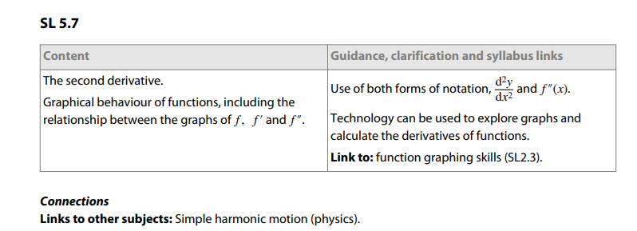

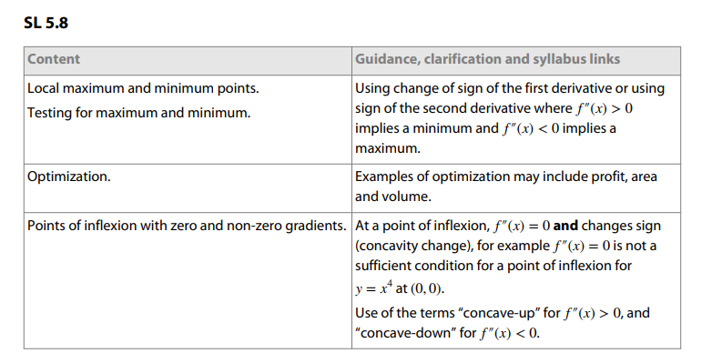

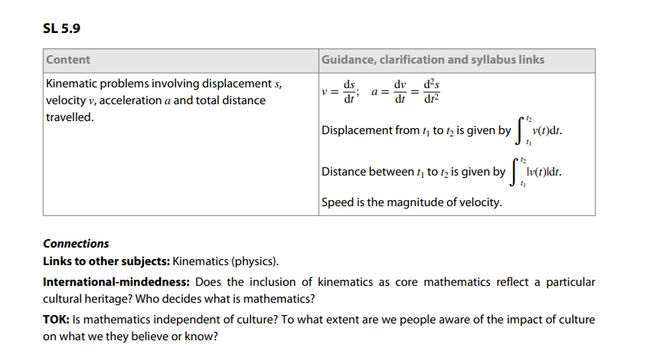

Learning Targets:

I am learning about what is happening with a function given the original function, first derivative and second derivative.

I am learning about the local maximum and minimum.

I am learning how to use the first and second derivative to text the maximum and minimum.

I am learning about optimization and how to find optimization and how it relates to the second derivative.

I am learning about kinematics.

Success Criteria:

I can find what is happening with a function given the original function, first derivative and second derivative.

I can identify the local maximum and minimum.

I can use the first and second derivative to text the maximum and minimum.

I can figure out how to find optimization and how it relates to the second derivative.

I can apply kinematics to the f, f’and f’’.

**Week at a Glance IB Analysis and Approaches Year 2**

Monday: Study for Chapter 5 Test

Tuesday: Study for Chapter 5 Test

Wednesday: Chapter 5 Test

Thursday: Learn from Home: Kinematics Video (3-2-1 Summary)

Friday: Learn from Home: Kinematics Video (3-2-1 Summary)